Guardrails Hub Setup Guide
What is Guardrails Hub?
Guardrails Hub is an open-source repository of validators built by the Guardrails AI community. These validators can be installed into your Python project to check and control LLM inputs and outputs — helping you build safe, reliable AI applications.

Why is the API Key Required?
The Guardrails Hub API key authenticates your local environment with the Hub, allowing you to install validators via the CLI. Without it, you cannot download or use validators from the Hub.

🔒 Access Validators  Install pre-built validators from the Hub into your project. | 🛡️ Validate LLM Output  Catch harmful, incorrect, or non-compliant AI responses.
⚡ Free Tier Available  Create your account at no cost. Free tier is sufficient for Week 8. | 🔧 CLI Integration  Configure once via guardrails configure and install validators instantly.

Prerequisites
Before you begin, ensure you have the following:
- Python 3.10 or higher installed
- pip package manager available
- guardrails-ai package (version 0.4.2+)

To install or upgrade guardrails-ai, run:
pip install guardrails-ai --upgrade

Step-by-Step: Create Your Guardrails Hub Key
Step 1: Go to the Guardrails Hub Keys Page
Open your browser and navigate to the following URL:
https://hub.guardrailsai.com/keys
Step 2: Sign Up or Log In
If you do not already have a Guardrails AI account, click Sign Up and create a free account using your email address. If you already have an account, log in with your credentials.
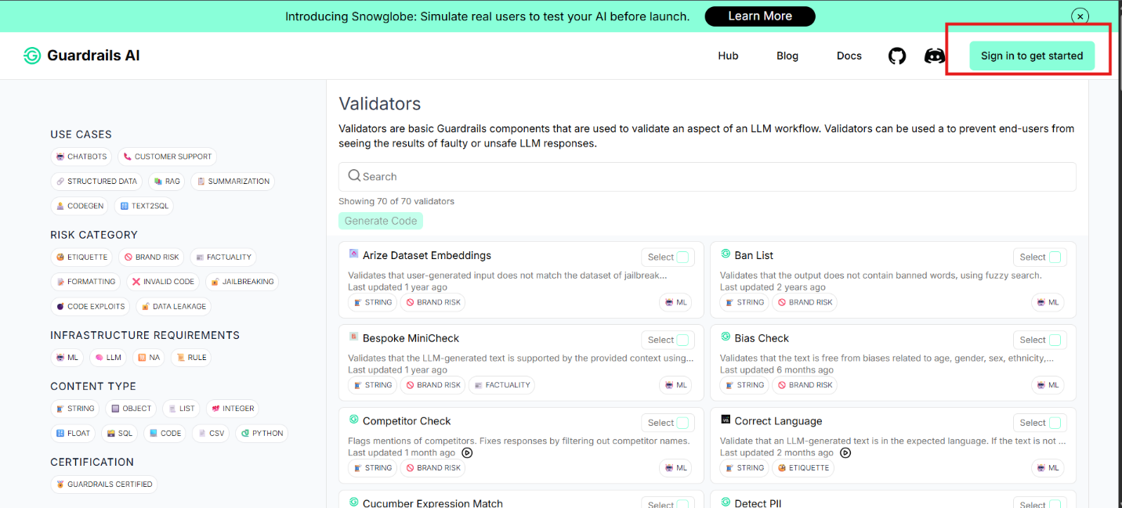

Step 3: Generate Your API Key
Once logged in, the API Keys page will display your available keys. Click the button to generate a new API key. Copy it immediately and store it somewhere safe — you will not be able to see it again after leaving the page.
- 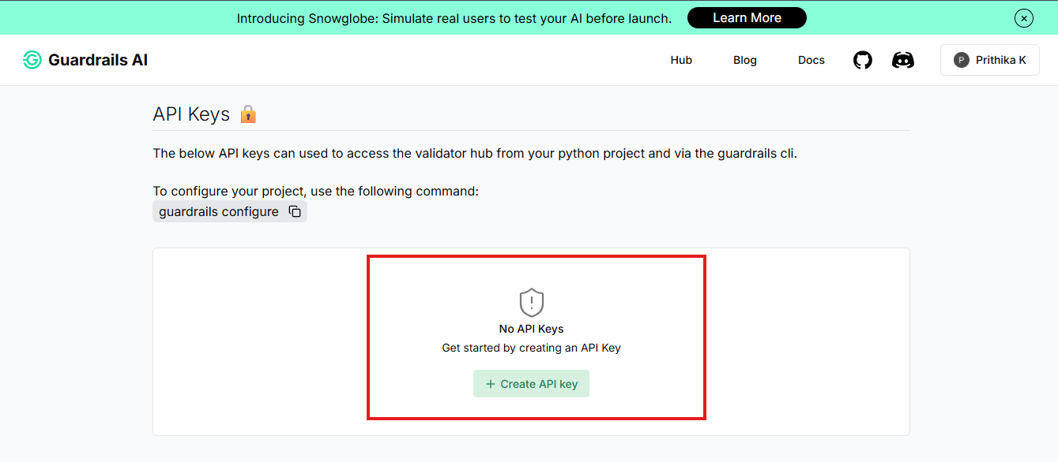

Step 4: Set the Environment Variable
Open Your Terminal
- Windows: Search for PowerShell or Command Prompt in the Start menu
- Mac: Open Terminal from Applications > Utilities
- Linux: Open your preferred terminal emulator
Set the Environment Variable
Run the command for your operating system:

Windows (PowerShell)
setx GUARDRAILS_API_KEY "your_api_key_here"

Mac / Linux (bash / zsh)
export GUARDRAILS_API_KEY="your_api_key_here"

For Python Projects — Use a .env File
In your project folder, create or open a file named .env and add:
.env file
GUARDRAILS_API_KEY=your_api_key_here

Step 5: Verify the Key in Python
Run a Quick Verification Script
Open a Python shell or create a small test file and run:

Python
import os

key = os.getenv("GUARDRAILS_API_KEY")
print(key)

Expected output: your key printed to the terminal (e.g., gr-xxxxxxxxxxxxxxxx).

ℹ️ Note
• | If it prints None: the environment variable is not set. Re-check Step 4.
• | Windows users: restart your terminal after running setx, then try again.

Test a Validator Install
Once the key is verified, confirm everything works end-to-end by installing a validator:

Python
from guardrails.hub import install

install("hub://guardrails/regex_match")

ℹ️ Note
• | Some validators require the API key to fetch from Hub — this confirms your key is working.
• | You can replace regex_match with any other validator from the Guardrails Hub.

Common Issues & Fixes
Issue | Likely Cause | Fix
Hub page won't load | Browser/network issue | Refresh, try incognito, or switch to hotspot
API key not working | guardrails-ai version too old | Run: pip install guardrails-ai --upgrade
Caret (^) chars in token | Ctrl+V used in PowerShell | Use right-click to paste in PowerShell
'Checking API Keys...' hangs | Not logged in / session expired | Sign out, sign back in via GitHub, refresh
Validator install fails | Key not configured / network issue | Re-run guardrails configure and retry

Useful Links
- Guardrails Hub Keys Page: https://hub.guardrailsai.com/keys
- Official Quickstart Docs: https://www.guardrailsai.com/docs/getting_started/quickstart
- Guardrails GitHub: https://github.com/guardrails-ai/guardrails
- Discord Community: https://discord.gg/kVZEnR4WQK

Week 8 SWE Onboarding | Guardrails Hub Setup Guide

